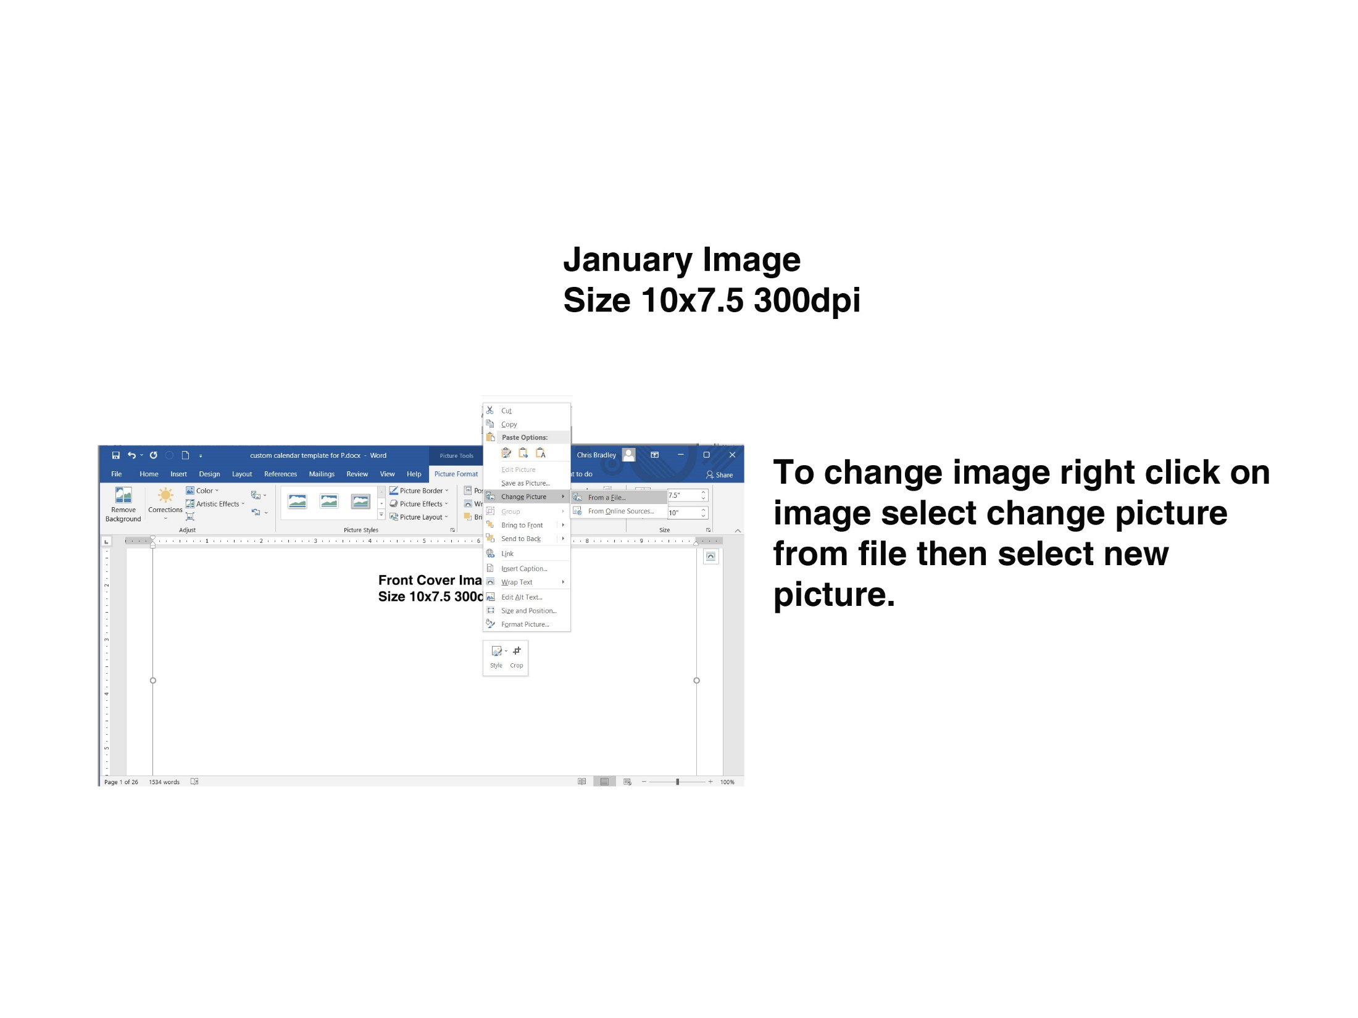
Dec 2023  S M T W T F S  1 2  3 4 5 6 7 8 9  10 11 12 13 14 15 16  17 18 19 20 21 22 23  24 25 26 27 28 29 30  31 |  |  | JAN 2024 |  |  | Feb 2024  S M T W T F S  1 2 3  4 5 6 7 8 9 10  11 12 13 14 15 16 17  18 19 20 21 22 23 24  25 26 27 28 29
SUNDAY |  | MONDAY | TUESDAY | WEDNESDAY | THURSDAY | FRIDAY | SATURDAY
 | 31 | 1 | 2 | 3 | 4 | 5 | 6
 |  | New Year's Day
 | 7 | 8 | 9 | 10 | 11 | 12 | 13
 | 14 | 15 | 16 | 17 | 18 | 19 | 20
 |  | M L King Day
 | 21 | 22 | 23 | 24 | 25 | 26 | 27
 | 28 | 29 | 30 | 31 | 1 | 2 | 3
________________________________________________________________________________________________________________________________________________________________________________________________________________________________________________________________________________________________________________________________________________________________________________________________________________________________________________________________________________________________
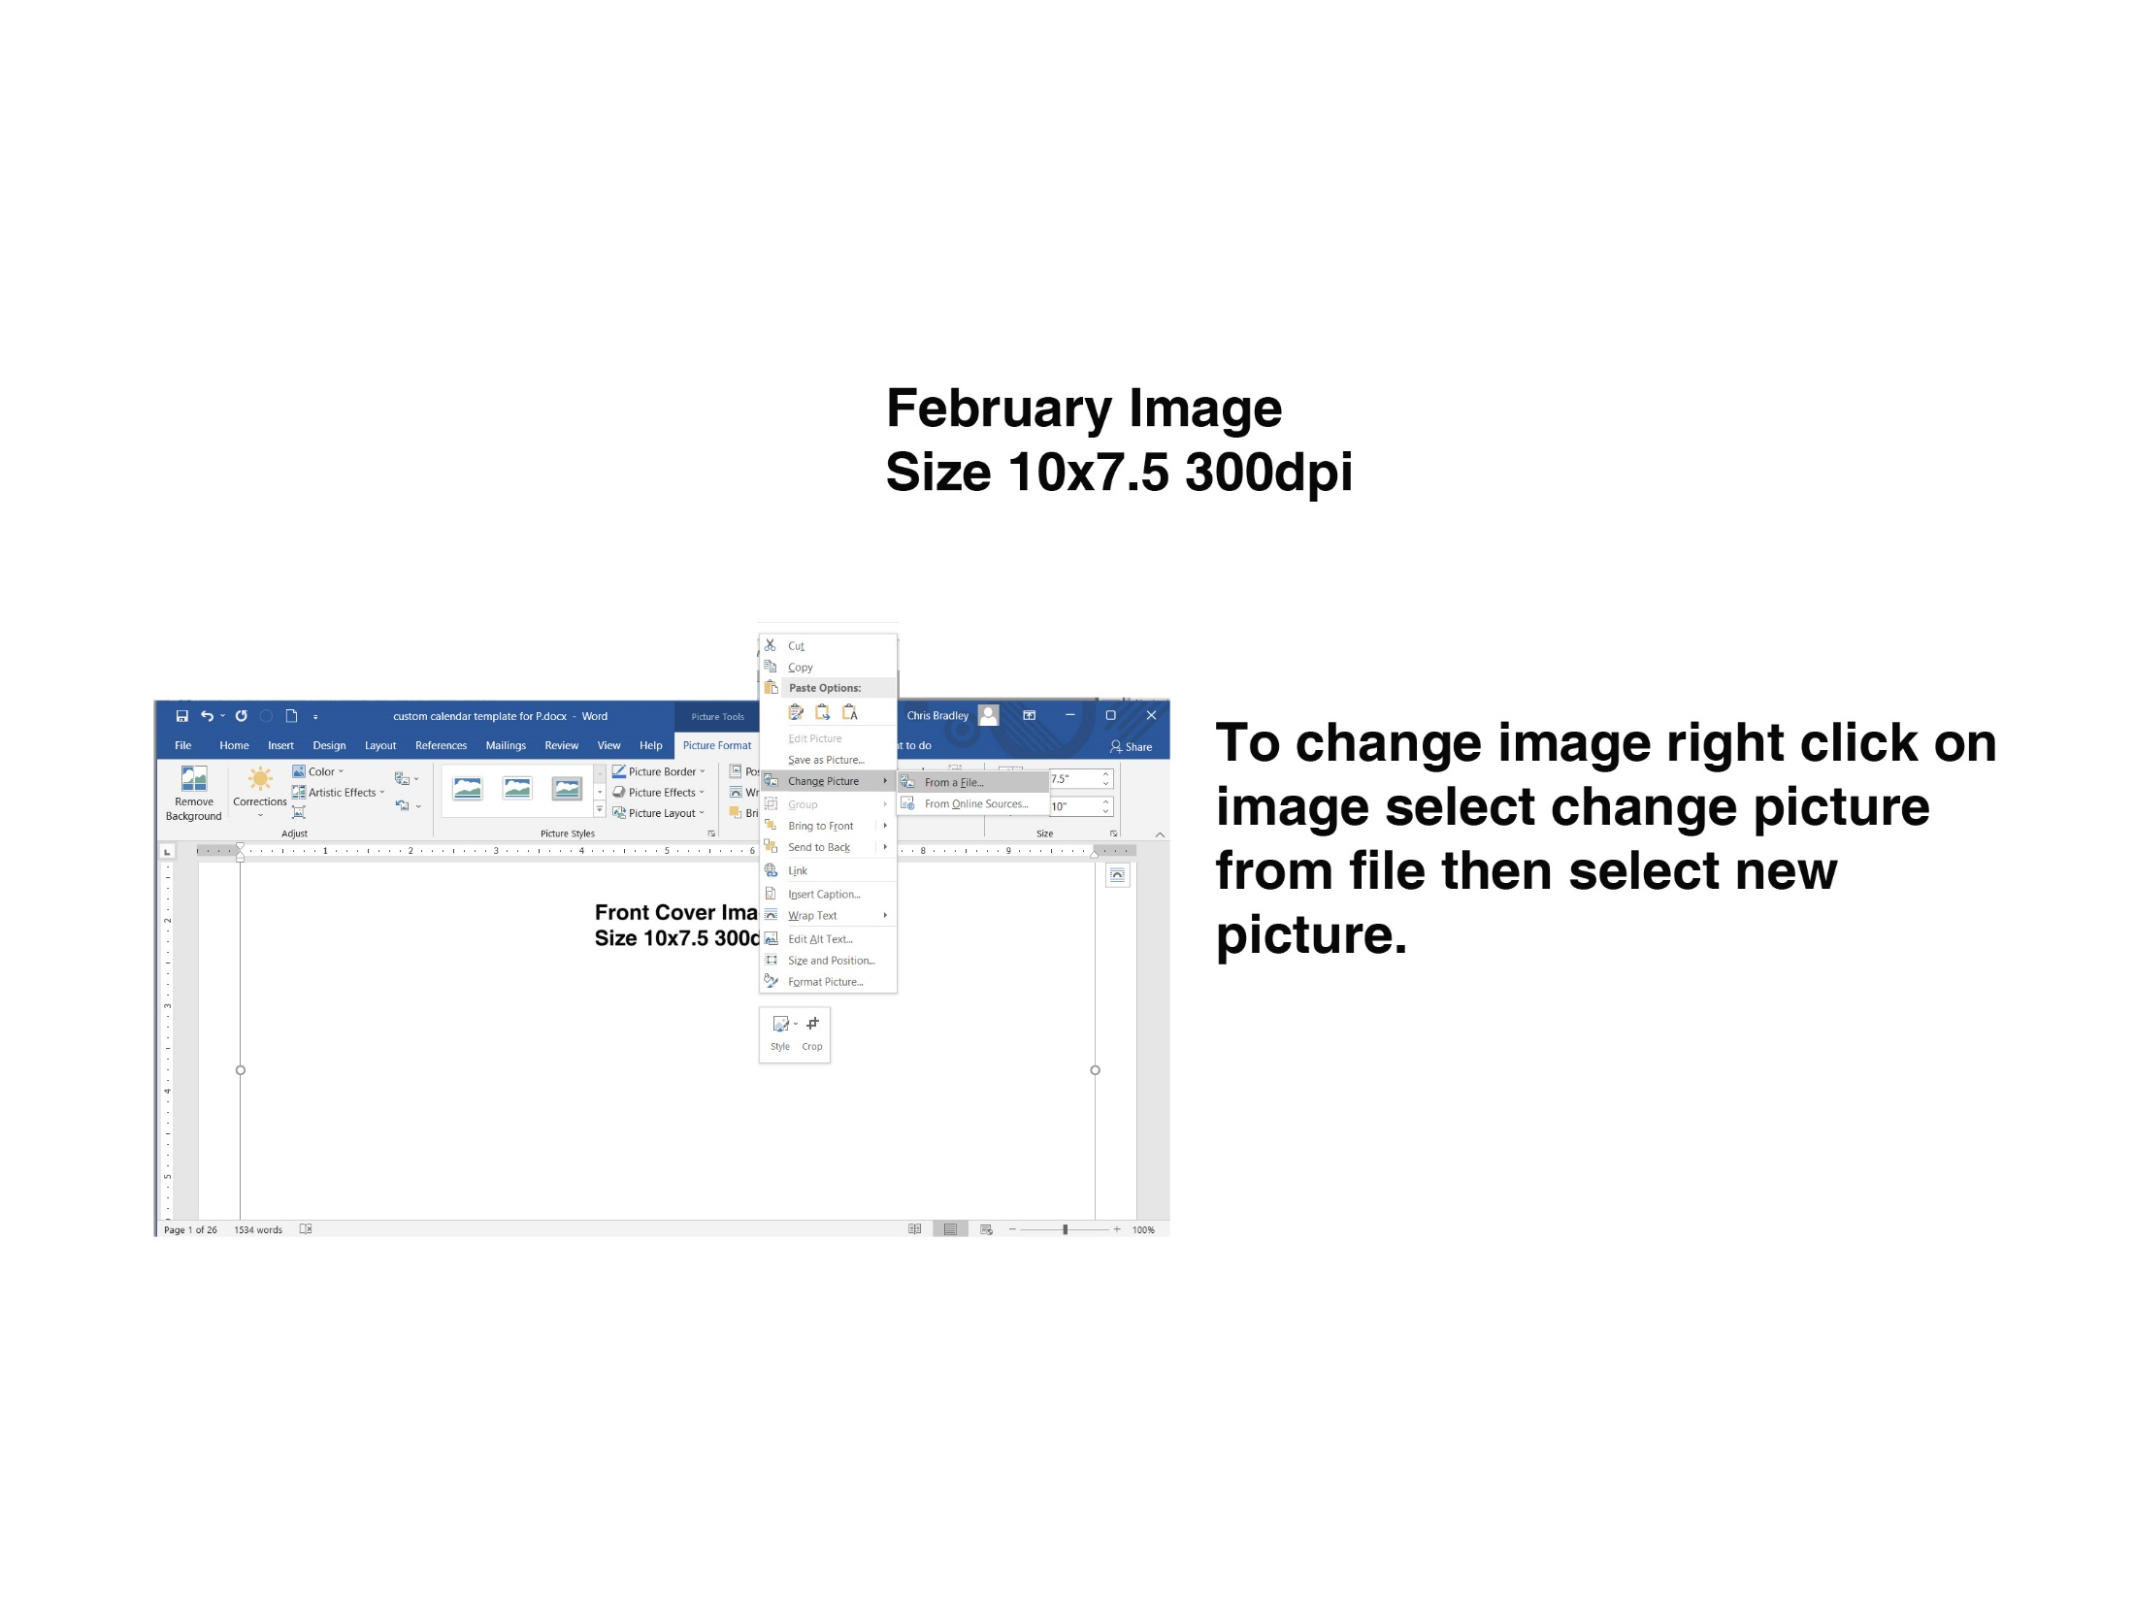
Jan 2024  S M T W T F S  1 2 3 4 5 6  7 8 9 10 11 12 13  14 15 16 17 18 19 20  21 22 23 24 25 26 27  28 29 30 31 |  |  | FEB 2024 |  |  | Mar 2024  S M T W T F S  1 2  3 4 5 6 7 8 9  10 11 12 13 14 15 16  17 18 19 20 21 22 23  24 25 26 27 28 29 30  31
SUNDAY |  | MONDAY | TUESDAY | WEDNESDAY | THURSDAY | FRIDAY | SATURDAY
 | 28 | 29 | 30 | 31 | 1 | 2 | 3
 | 4 | 5 | 6 | 7 | 8 | 9 | 10
 | 11 | 12 | 13 | 14 | 15 | 16 | 17
 |  |  |  | Valentine's Day
 | 18 | 19 | 20 | 21 | 22 | 23 | 24
 |  | Presidents' Day
 | 25 | 26 | 27 | 28 | 29 | 1 | 2
________________________________________________________________________________________________________________________________________________________________________________________________________________________________________________________________________________________________________________________________________________________________________________________________________________________________________________________________________________________________________________________________________________________________________________________________________________________
Feb 2024  S M T W T F S  1 2 3  4 5 6 7 8 9 10  11 12 13 14 15 16 17  18 19 20 21 22 23 24  25 26 27 28 29 |  |  | MAR 2024 |  |  | Apr 2024  S M T W T F S  1 2 3 4 5 6  7 8 9 10 11 12 13  14 15 16 17 18 19 20  21 22 23 24 25 26 27  28 29 30
SUNDAY |  | MONDAY | TUESDAY | WEDNESDAY | THURSDAY | FRIDAY | SATURDAY
 | 25 | 26 | 27 | 28 | 29 | 1 | 2
 | 3 | 4 | 5 | 6 | 7 | 8 | 9
 | 10 | 11 | 12 | 13 | 14 | 15 | 16
 | 17 | 18 | 19 | 20 | 21 | 22 | 23
 | 24 | 25 | 26 | 27 | 28 | 29 | 30
 |  |  |  |  |  | Good Friday
 | 31 | 1 | 2 | 3 | 4 | 5 | 6
Easter Sunday
________________________________________________________________________________________________________________________________________________________________________________________________________________________________________________________________________________________________________________________________________________________________________________________________________________________________________________________________________________________________________________________________________________________________________________________________________________________
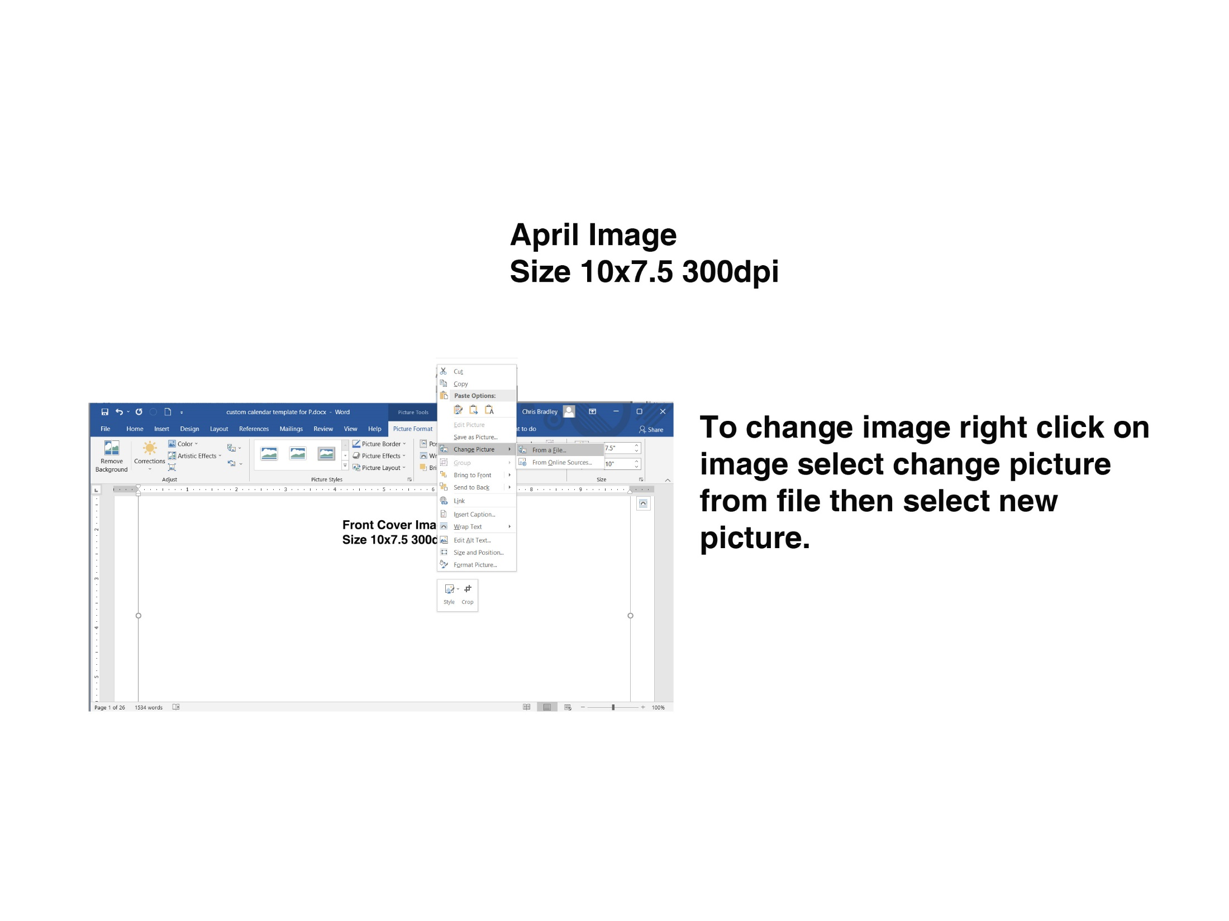
Mar 2024  S M T W T F S  1 2  3 4 5 6 7 8 9  10 11 12 13 14 15 16  17 18 19 20 21 22 23  24 25 26 27 28 29 30  31 |  |  | APR 2024 |  |  | May 2024  S M T W T F S  1 2 3 4  5 6 7 8 9 10 11  12 13 14 15 16 17 18  19 20 21 22 23 24 25  26 27 28 29 30 31
SUNDAY |  | MONDAY | TUESDAY | WEDNESDAY | THURSDAY | FRIDAY | SATURDAY
 | 31 | 1 | 2 | 3 | 4 | 5 | 6
 | 7 | 8 | 9 | 10 | 11 | 12 | 13
 | 14 | 15 | 16 | 17 | 18 | 19 | 20
 | 21 | 22 | 23 | 24 | 25 | 26 | 27
 | 28 | 29 | 30 | 1 | 2 | 3 | 4
________________________________________________________________________________________________________________________________________________________________________________________________________________________________________________________________________________________________________________________________________________________________________________________________________________________________________________________________________________________________________________________________________________________________________________________________________________________
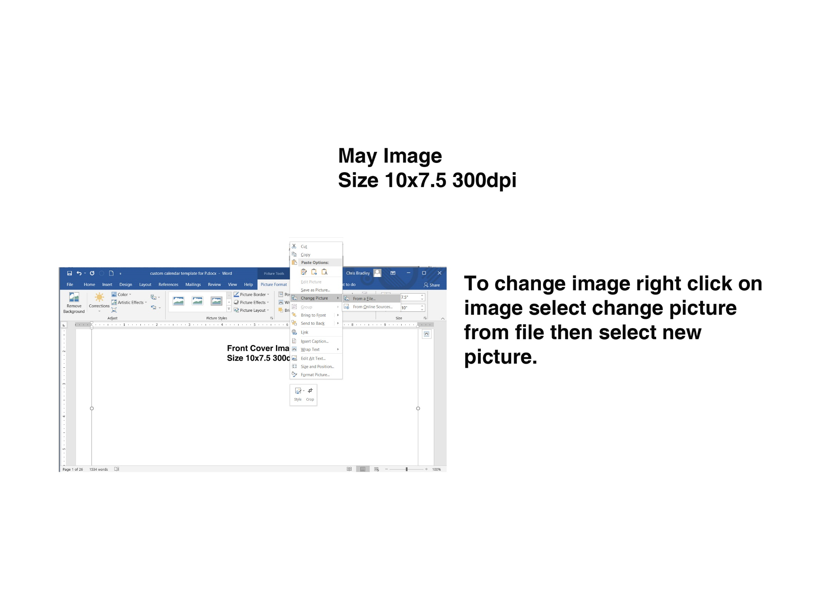
Apr 2024  S M T W T F S  1 2 3 4 5 6  7 8 9 10 11 12 13  14 15 16 17 18 19 20  21 22 23 24 25 26 27  28 29 30 |  |  | MAY 2024 |  |  | Jun 2024  S M T W T F S  1  2 3 4 5 6 7 8  9 10 11 12 13 14 15  16 17 18 19 20 21 22  23 24 25 26 27 28 29  30
SUNDAY |  | MONDAY | TUESDAY | WEDNESDAY | THURSDAY | FRIDAY | SATURDAY
 | 28 | 29 | 30 | 1 | 2 | 3 | 4
 | 5 | 6 | 7 | 8 | 9 | 10 | 11
 | 12 | 13 | 14 | 15 | 16 | 17 | 18
Mother's Day
 | 19 | 20 | 21 | 22 | 23 | 24 | 25
 | 26 | 27 | 28 | 29 | 30 | 31 | 1
 |  | Memorial Day
________________________________________________________________________________________________________________________________________________________________________________________________________________________________________________________________________________________________________________________________________________________________________________________________________________________________________________________________________________________________________________________________________________________________________________________________________________________
May 2024  S M T W T F S  1 2 3 4  5 6 7 8 9 10 11  12 13 14 15 16 17 18  19 20 21 22 23 24 25  26 27 28 29 30 31 |  |  | JUN 2024 |  |  | Jul 2024  S M T W T F S  1 2 3 4 5 6  7 8 9 10 11 12 13  14 15 16 17 18 19 20  21 22 23 24 25 26 27  28 29 30 31
SUNDAY |  | MONDAY | TUESDAY | WEDNESDAY | THURSDAY | FRIDAY | SATURDAY
 | 26 | 27 | 28 | 29 | 30 | 31 | 1
 | 2 | 3 | 4 | 5 | 6 | 7 | 8
 |  |  |  |  |  | National Donut Day
 | 9 | 10 | 11 | 12 | 13 | 14 | 15
 | 16 | 17 | 18 | 19 | 20 | 21 | 22
Father's Day
 | 23 | 24 | 25 | 26 | 27 | 28 | 29
 | 30 | 1 | 2 | 3 | 4 | 5 | 6
________________________________________________________________________________________________________________________________________________________________________________________________________________________________________________________________________________________________________________________________________________________________________________________________________________________________________________________________________________________________________________________________________________________________________________________________________________________
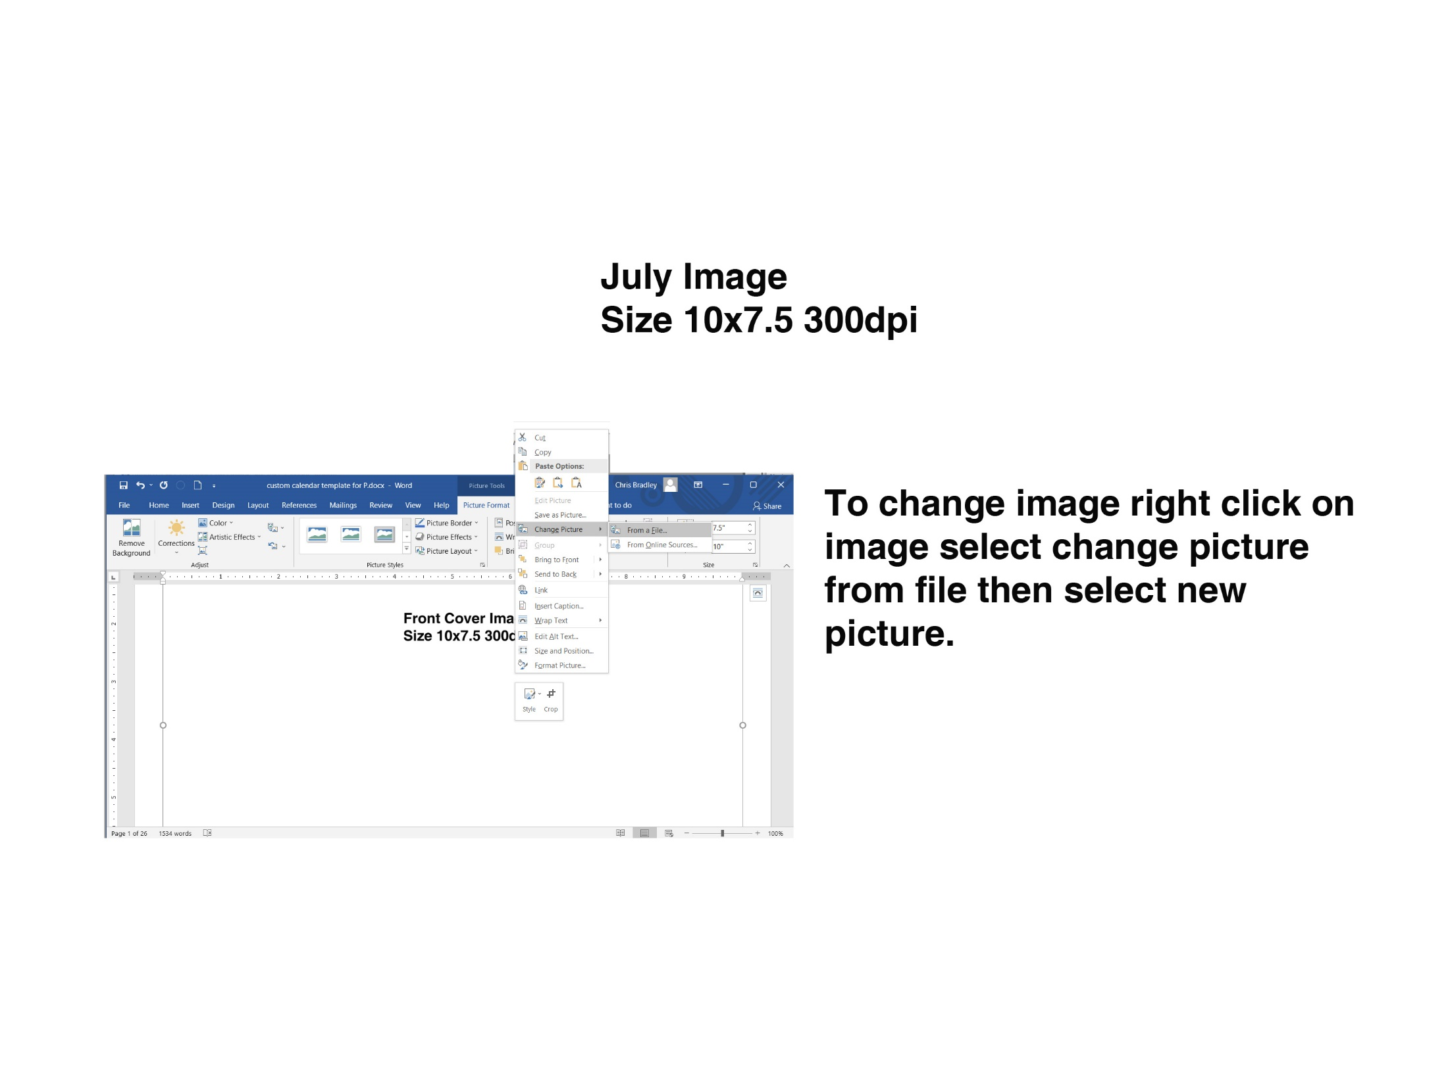
Jun 2024  S M T W T F S  1  2 3 4 5 6 7 8  9 10 11 12 13 14 15  16 17 18 19 20 21 22  23 24 25 26 27 28 29  30 |  |  | JUL 2024 |  |  | Aug 2024  S M T W T F S  1 2 3  4 5 6 7 8 9 10  11 12 13 14 15 16 17  18 19 20 21 22 23 24  25 26 27 28 29 30 31
SUNDAY |  | MONDAY | TUESDAY | WEDNESDAY | THURSDAY | FRIDAY | SATURDAY
 | 30 | 1 | 2 | 3 | 4 | 5 | 6
 |  |  |  |  | Independence Day
 | 7 | 8 | 9 | 10 | 11 | 12 | 13
 | 14 | 15 | 16 | 17 | 18 | 19 | 20
 | 21 | 22 | 23 | 24 | 25 | 26 | 27
 | 28 | 29 | 30 | 31 | 1 | 2 | 3
________________________________________________________________________________________________________________________________________________________________________________________________________________________________________________________________________________________________________________________________________________________________________________________________________________________________________________________________________________________________________________________________________________________________________________________________________________________
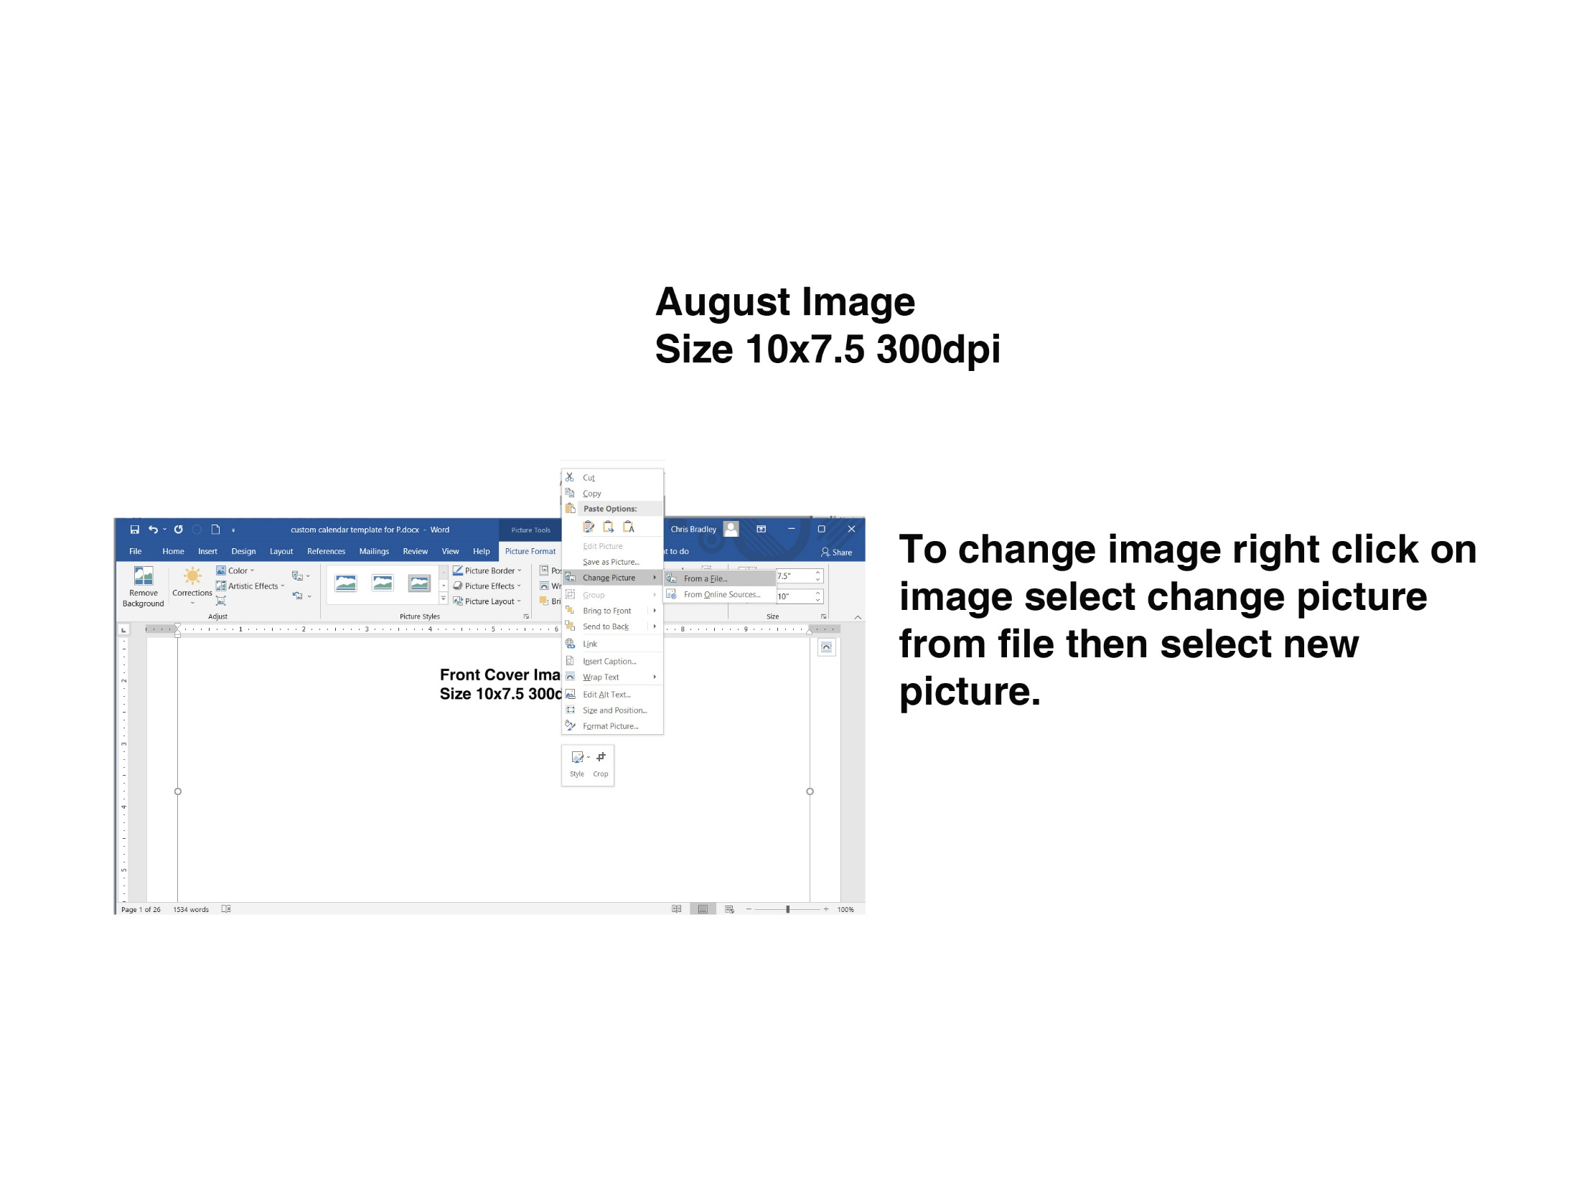
Jul 2024  S M T W T F S  1 2 3 4 5 6  7 8 9 10 11 12 13  14 15 16 17 18 19 20  21 22 23 24 25 26 27  28 29 30 31 |  |  | AUG 2024 |  |  | Sep 2024  S M T W T F S  1 2 3 4 5 6 7  8 9 10 11 12 13 14  15 16 17 18 19 20 21  22 23 24 25 26 27 28  29 30
SUNDAY |  | MONDAY | TUESDAY | WEDNESDAY | THURSDAY | FRIDAY | SATURDAY
 | 28 | 29 | 30 | 31 | 1 | 2 | 3
 | 4 | 5 | 6 | 7 | 8 | 9 | 10
 | 11 | 12 | 13 | 14 | 15 | 16 | 17
 | 18 | 19 | 20 | 21 | 22 | 23 | 24
 | 25 | 26 | 27 | 28 | 29 | 30 | 31
________________________________________________________________________________________________________________________________________________________________________________________________________________________________________________________________________________________________________________________________________________________________________________________________________________________________________________________________________________________________________________________________________________________________________________________________________________________
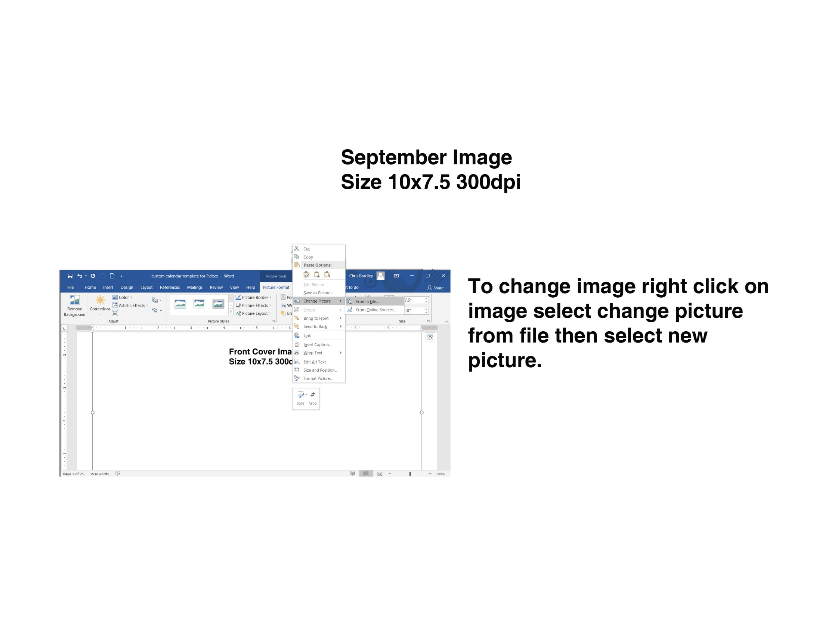
Aug 2024  S M T W T F S  1 2 3  4 5 6 7 8 9 10  11 12 13 14 15 16 17  18 19 20 21 22 23 24  25 26 27 28 29 30 31 |  |  | SEP 2024 |  |  | Oct 2024  S M T W T F S  1 2 3 4 5  6 7 8 9 10 11 12  13 14 15 16 17 18 19  20 21 22 23 24 25 26  27 28 29 30 31
SUNDAY |  | MONDAY | TUESDAY | WEDNESDAY | THURSDAY | FRIDAY | SATURDAY
 | 1 | 2 | 3 | 4 | 5 | 6 | 7
 |  | Labor Day
 | 8 | 9 | 10 | 11 | 12 | 13 | 14
 | 15 | 16 | 17 | 18 | 19 | 20 | 21
 | 22 | 23 | 24 | 25 | 26 | 27 | 28
 | 29 | 30 | 1 | 2 | 3 | 4 | 5
________________________________________________________________________________________________________________________________________________________________________________________________________________________________________________________________________________________________________________________________________________________________________________________________________________________________________________________________________________________________________________________________________________________________________________________________________________________
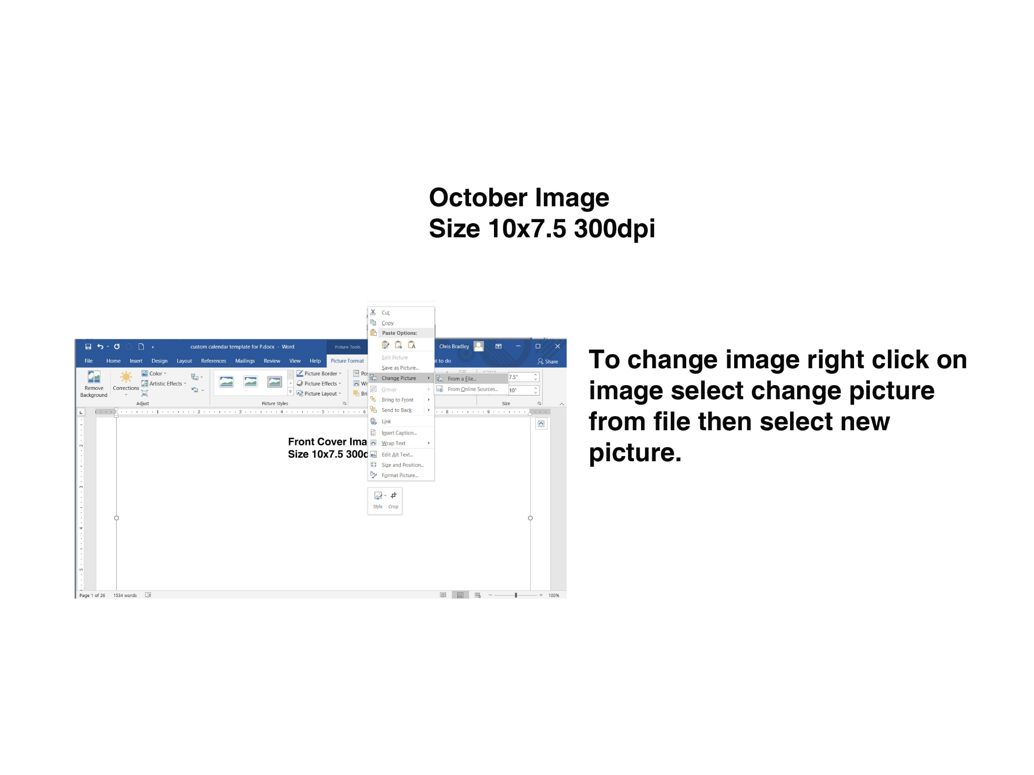
Sep 2024  S M T W T F S  1 2 3 4 5 6 7  8 9 10 11 12 13 14  15 16 17 18 19 20 21  22 23 24 25 26 27 28  29 30 |  |  | OCT 2024 |  |  | Nov 2024  S M T W T F S  1 2  3 4 5 6 7 8 9  10 11 12 13 14 15 16  17 18 19 20 21 22 23  24 25 26 27 28 29 30
SUNDAY |  | MONDAY | TUESDAY | WEDNESDAY | THURSDAY | FRIDAY | SATURDAY
 | 29 | 30 | 1 | 2 | 3 | 4 | 5
 | 6 | 7 | 8 | 9 | 10 | 11 | 12
 | 13 | 14 | 15 | 16 | 17 | 18 | 19
 |  | Columbus Day
 | 20 | 21 | 22 | 23 | 24 | 25 | 26
 | 27 | 28 | 29 | 30 | 31 | 1 | 2
 |  |  |  |  | Halloween
________________________________________________________________________________________________________________________________________________________________________________________________________________________________________________________________________________________________________________________________________________________________________________________________________________________________________________________________________________________________________________________________________________________________________________________________________________________
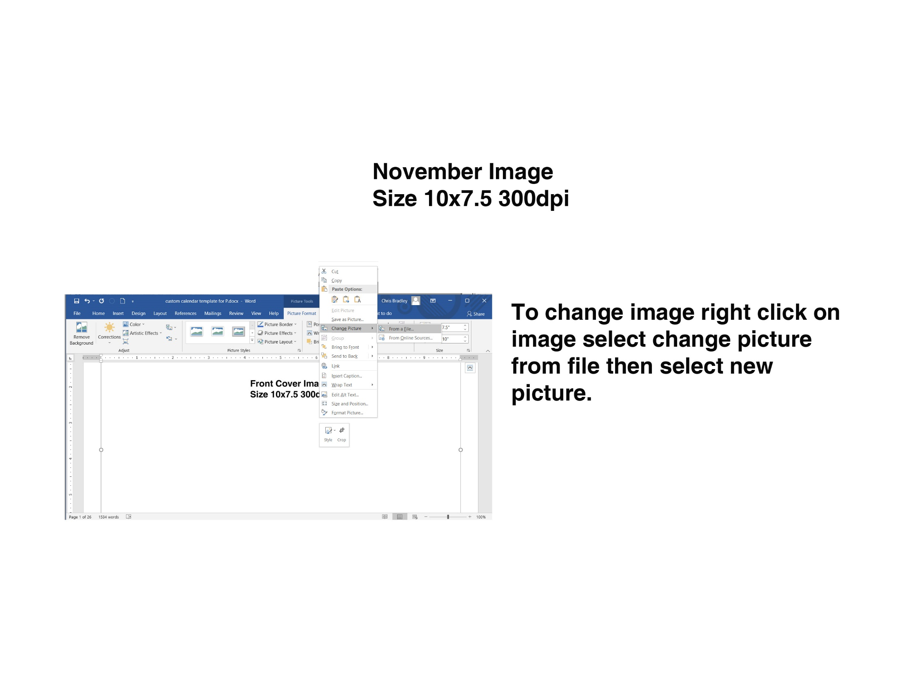
Oct 2024  S M T W T F S  1 2 3 4 5  6 7 8 9 10 11 12  13 14 15 16 17 18 19  20 21 22 23 24 25 26  27 28 29 30 31 |  |  | NOV 2024 |  |  | Dec 2024  S M T W T F S  1 2 3 4 5 6 7  8 9 10 11 12 13 14  15 16 17 18 19 20 21  22 23 24 25 26 27 28  29 30 31
SUNDAY |  | MONDAY | TUESDAY | WEDNESDAY | THURSDAY | FRIDAY | SATURDAY
 | 27 | 28 | 29 | 30 | 31 | 1 | 2
 | 3 | 4 | 5 | 6 | 7 | 8 | 9
 | 10 | 11 | 12 | 13 | 14 | 15 | 16
 |  | Veterans Day
 | 17 | 18 | 19 | 20 | 21 | 22 | 23
 | 24 | 25 | 26 | 27 | 28 | 29 | 30
 |  |  |  |  | Thanksgiving Day
________________________________________________________________________________________________________________________________________________________________________________________________________________________________________________________________________________________________________________________________________________________________________________________________________________________________________________________________________________________________________________________________________________________________________________________________________________________
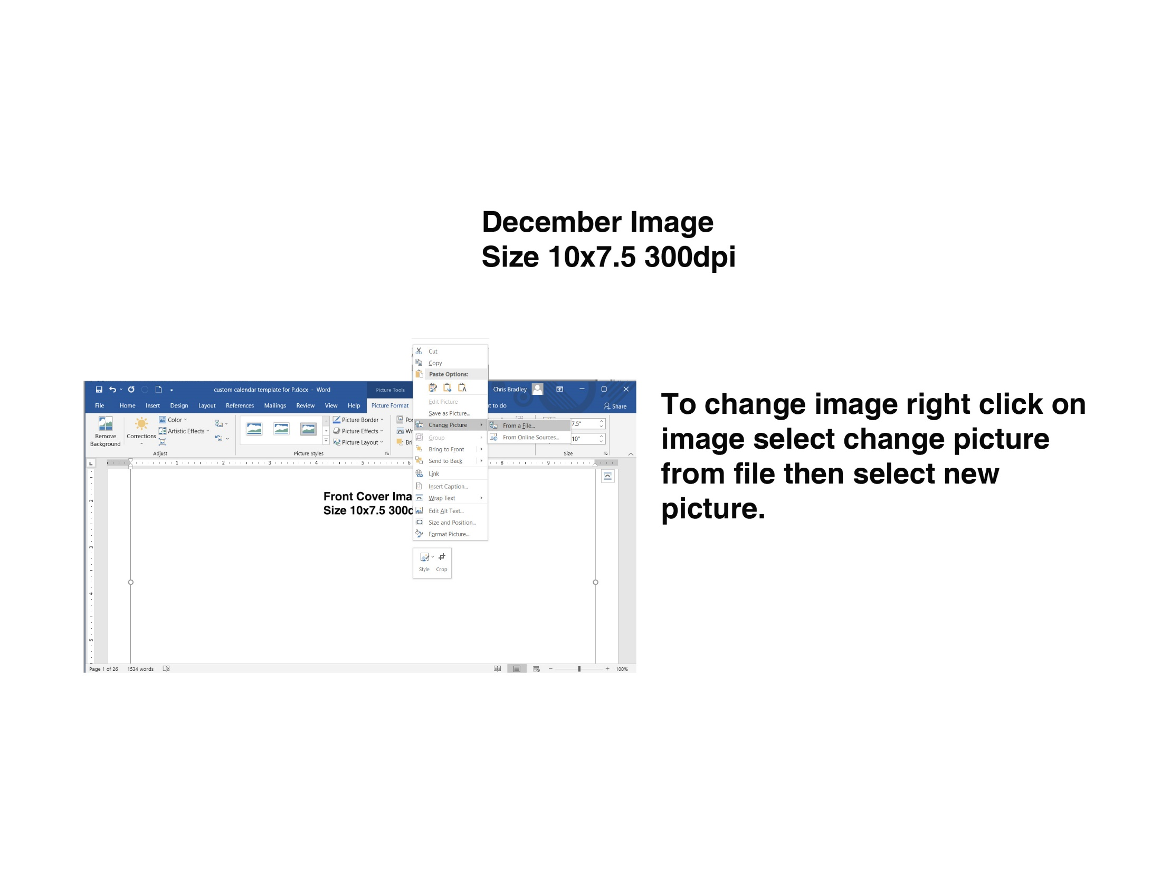
Nov 2024  S M T W T F S  1 2  3 4 5 6 7 8 9  10 11 12 13 14 15 16  17 18 19 20 21 22 23  24 25 26 27 28 29 30 |  |  | DEC 2024 |  |  | Jan 2025  S M T W T F S  1 2 3 4  5 6 7 8 9 10 11  12 13 14 15 16 17 18  19 20 21 22 23 24 25  26 27 28 29 30 31
SUNDAY |  | MONDAY | TUESDAY | WEDNESDAY | THURSDAY | FRIDAY | SATURDAY
 | 1 | 2 | 3 | 4 | 5 | 6 | 7
 | 8 | 9 | 10 | 11 | 12 | 13 | 14
 | 15 | 16 | 17 | 18 | 19 | 20 | 21
 | 22 | 23 | 24 | 25 | 26 | 27 | 28
 |  |  |  | Christmas
 | 29 | 30 | 31 | 1 | 2 | 3 | 4
________________________________________________________________________________________________________________________________________________________________________________________________________________________________________________________________________________________________________________________________________________________________________________________________________________________________________________________________________________________________________________________________________________________________________________________________________________________
Additional 2 pages in back can be used for images or text delete this text before saving but leave pages.

Additional 2 pages in back can be used for images or text delete this text before saving but leave pages.

